MORNING WORSHIP SERVICE
Sept 18, 2016

Opening “All Hail King Jesus”

Opening Prayer/Announcements
K s b c

Keeping His Word through Sunday School, Bible Study and Church Attendance/Worship

Sunday School Bible Studies for September:

Sept 4th One Great Creator Ps 33:6-9,13-15; Col. 1:15-17
Sept 11th One Great Purpose Isaiah 43:1-7
Sept 18th One Great Problem Romans 3:9-12,19-20,23
Sept 25th One Great Savior Romans 5:6-11

9:45 a.m. each Sunday – A place for everyone

Worship Hymns “All Hail The Power of Jesus’ Name” 202
“Awesome God”
“Jesus Loves Me” 344
“Worthy of Worship” 3
Holy Is The Lord” 9

Offering/Offertory

Special Music Sharon Harbison

Message Bro. David Atwood

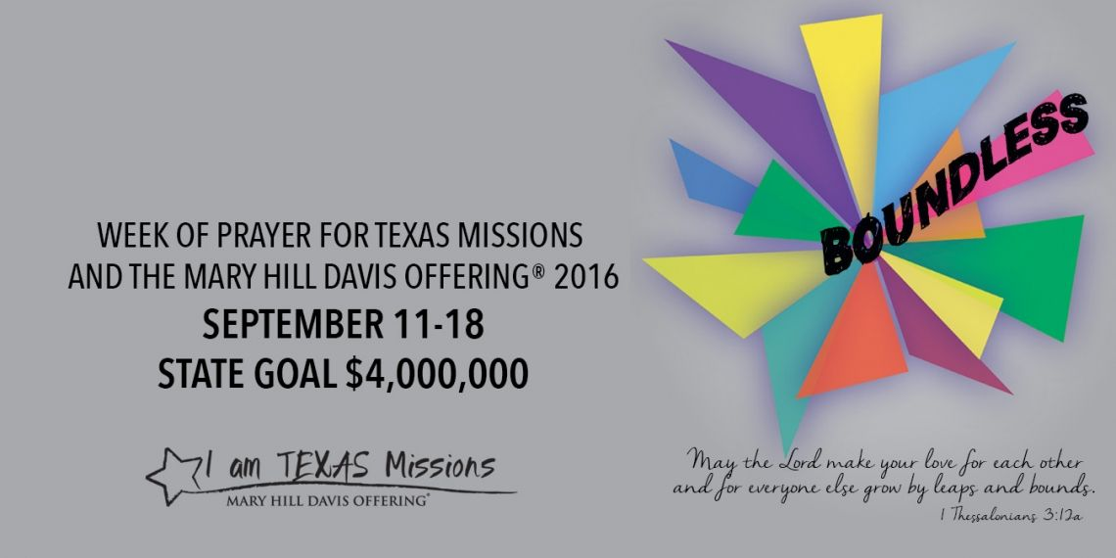

Invitation “Where He Leads Me” 288

Closing Prayer

Evening Service @ 6:00pm

NURSERY – available for children age 0 to Kindergarten
Teresa Schane, Angie Fisher

Hostesses for September Ushers for September
Brenda Williams, Evelyn Robinson, Jack Radford, Tom Veilleux,
Judy Broussard Joe Wilson, Wayne Marecle

Immediate Need Prayer List
Prayer & Request Information

(Please complete name & address information on reverse side)

❑ I would like to speak with the Pastor.

❑ I would like more information on this church.

❑ I have Prayer Requests or Needs

Date:

Permission to Publicize:
Church Bulletin  Yes  No
Email Prayer Chain  Yes  No

Prayer Request:

Prayer For
Name
Address
Phone

Given By
Name
Address
Phone
Please Contact By

❑ Card  Phone  Visit

Comments

Pray for Dwight Reagan as he recovers from surgery (he’s doing great)

Pray for Karlie Griffith as she recovers from surgery

Pray for Helen Emery, she is not adjusting well to her new surroundings

